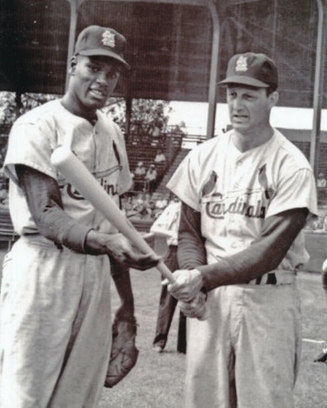

Bob Gibson and Stan Musial,
Spring Training 1961, Tampa Bay

Angry no more.

FROM THE BULLPEN

2020 Campaign Edition No. 18 September 11, 2020

NINE ELEVEN

Gentlemen:

As I began dictating this week’s edition of From the Bullpen, I realized that today is the 19th anniversary of the 9/11 terrorist attacks on the World Trade Center and the Pentagon. Wow, nineteen years. I am sure that all of you, like me, know exactly where you were when you learned of the attacks. I was in Springfield, Missouri, just having finished up a morning jog before cleaning up in my hotel and heading to a deposition, when I walked through the hotel dining area and saw a replay of the first interliner strike on the Towers. Absolutely surreal. Later that day, after the deposition, I drove from Springfield and remember the eerie feeling of not seeing a single plan e in the sky, while listening to radio news reports to find out more about the full scope of the attacks.

I also remember our then-POTUS, George W. Bush, doing a pretty good job of keeping our nation calm in the aftermath of these heinous attacks, rallying justice for the victims but not hitting the panic button and lobbing a couple of nukes over in the general direction of Afghanistan where Osama

