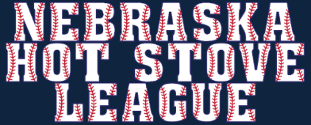
`
2020 HSL Champion
West Des Moines Cubs
Manager: Shamu
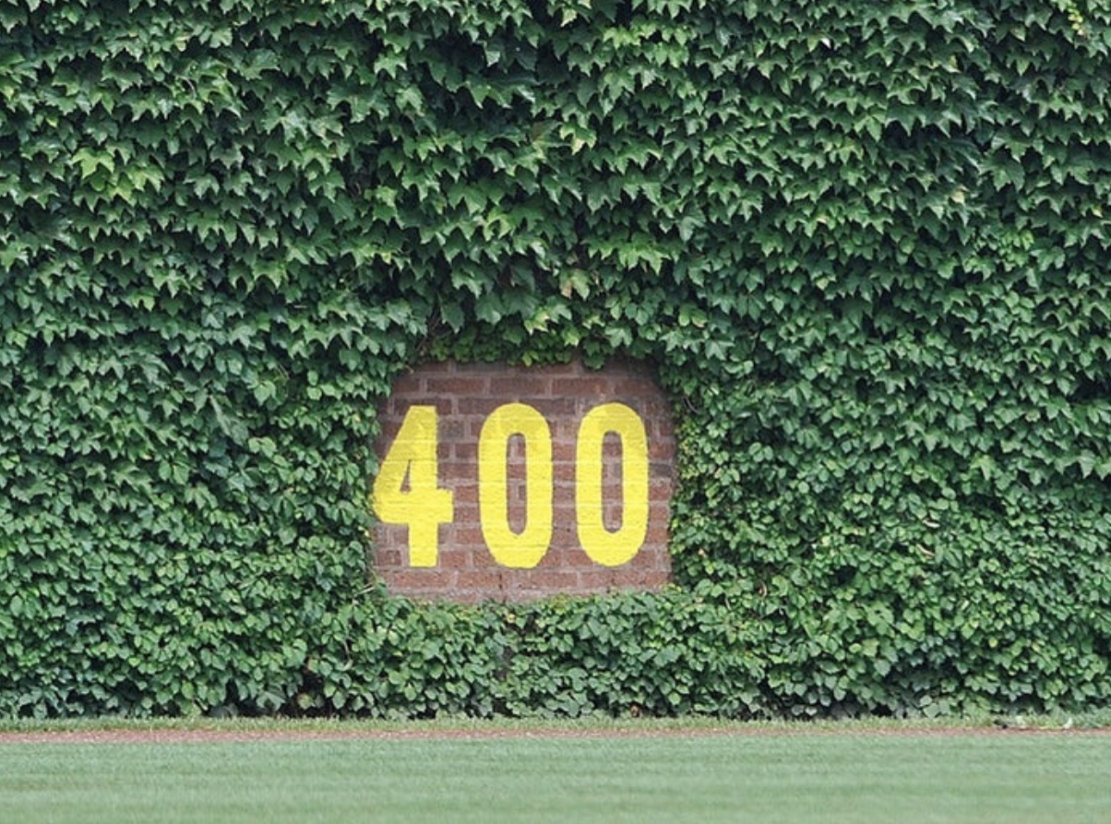
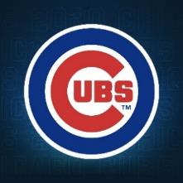
SEASON XXXVII

FROM THE BULLPEN

2021 Campaign Edition No. 25 November 10, 2021

Hombres:

Welcome to Edition No. 26 of the 2021 From the Bullpen. Lots to cover this issue, so let’s get started, shall we?

I. BRAVES WIN!

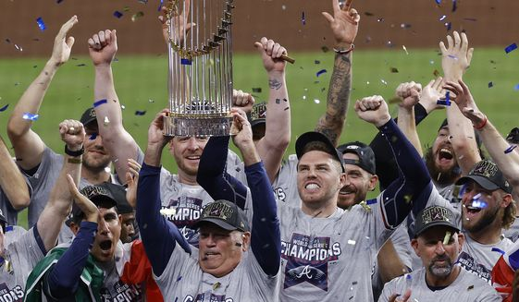

Congratulations to the Atlanta Braves for their six-game victory over the cheatin’ Astros in this year’s edition of the Fall Classic. As you all know, this is only the second time that the Braves have ended up a season as the World Champions since they have been in Atlanta, their first title dating back to 1995, the year Forrest Gump Won the Academy Award for Best Picture. It was the fourth overall World Series victory for this long-time National League franchise, including their first title in 1914 when they were the (Miracle) Boston Braves, and their crown in Milwaukee in 1957 when Hank Aaron, Eddie Mathews and Lew Burdette (3 pitching wins) led the Braves to a 4-3 win over the powerhouse Yankees.

Congratulations also and especially to our Webmaster and Den Mother Linda, who has been an ardent and patient Braves fan for many a campaign. I have it on good authority that Linda watched every single regular season and playoff game this season, and so if ever a fan deserved to be rewarded with a World Series championship, it is Superfan Linda. Well played, Mauer.

II. A NOD TO NATIONAL PARKS

On October 21, HQ and I traveled to Phoenix so that we could share a birthday dinner with Savannah, Emily, Molly and Shanell, followed by a day in Sedona involving a Jeep tour and then a day pontooning on beautiful Lake Saguaro, both of which were outstanding. The original game plan had been for HQ and me to then fly to Eugene, Oregon, then drive down to Crater Lake National Park, then drive down to Redwood National Park in Northern California, and then to drive up the Oregon coastline for a week of sightseeing and repose. The specifics of this little vacation driving trip were supposed to be a surprise, but when Michele asked me to at least let her know what she should pack to wear on the trip, my hand was forced and I had to check the weather forecast in Northern California and Oregon for that week, which to my surprise and chagrin called for temperatures in the 40’s and 50’s and rain every single day. Crestfallen but not defeated, we pulled perhaps our best vacation audible ever and redirected our travel plans to Northern Arizona and Southern Utah. I will spare you all the minute details, but below are a few of the highlights.

As we headed north from Phoenix toward Flagstaff with an initial visit to the Grand Canyon on the radar, we saw an exit sign for something called Montezuma Castle, which, because of its appearance on my nifty map of National Parks and Other Historic Places, warranted a stop for a quick look, and a most provident stop it was. For it was here that I learned that due to my advanced age I qualified for a Lifetime Pass to all of the National Parks and other Federal Recreational Lands for the low, low price of $80. Some of you may already know about this, but if you don’t, it is one of the sweetest deals of all time, because not only does it get me and HQ into all of our National Parks and other historic places for the rest of perpetuity, but it also allows me to bring along two other guests--kicking, screaming or otherwise. Since most National Parks cost 25 or 30 bucks apiece just to get in the gate, this little investment has already paid off in spades, and we are just getting started. Bully.

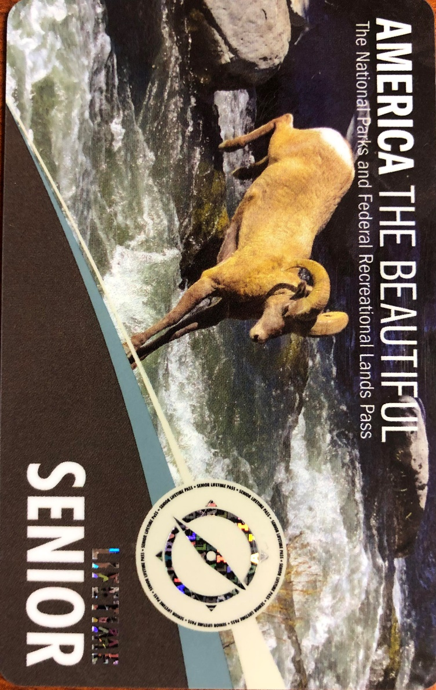

MONTEZUMA CASTLE MISNOMER

The picture below is the Montezuma Castle National Monument located fifty miles south of Flagstaff. Contrary to logic and fact, this structure was not built nor occupied by Montezuma, and was not and has never been a “castle.” In other words, fake news. Instead, this five-story, twenty-five room dwelling was built by Southern Sinagua farmers at some point between 1100 and 1300 A.D. It is impressive to see and ponder, and best of all, it earned me another stamp in my nifty National Parks passport book.

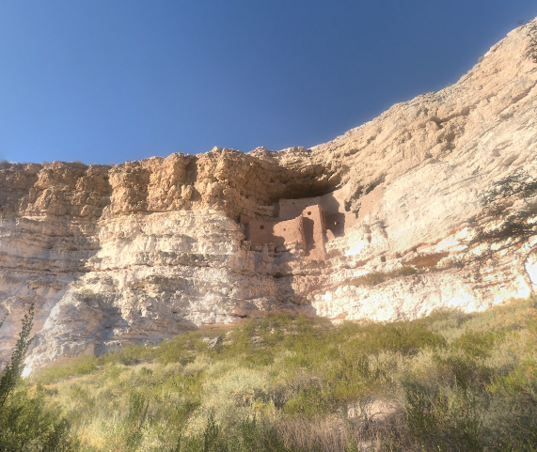
Montezuma Castle National Monument

FLAGSTAFF AND THE GRAND CANYON

After our obligatory stop at the Montezuma Castle, we were back on the road and took the beautiful scenic highway known as Highway 89A from Sedona to Flagstaff, where we bunkered in for the night. If you ever have a chance to make this drive, I heartily recommend it, particularly when the fall colors are in full season. We found Flagstaff to be a charming little mountain town, home to Northern Arizona University, and learned that it gets the second greatest amount of snowfall among all American cities on an annual basis, second only to Syracuse. Flagstaff has a popular ski resort known as the Arizona Snowbowl, where they advertise a whopping 260 inches of snowfall on average.

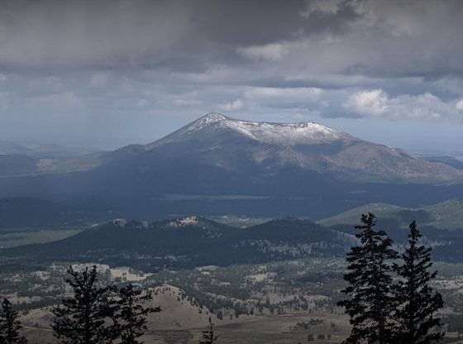

We spent a couple of hours walking the Canyon Rim Trail, snapping photos and repeatedly resisting the urge to take a fatal leap off the edge into nothingness, a weird urge that seems to be a part of our genetic makeup. Fortunately, nobody has successfully executed upon it yet, and so after a couple of hours looking at the second biggest damn hole in the world, we were on our way north and east toward Page, Arizona, a little town that sprung up out of nowhere with the decision to dam up the Colorado River and make Lake Powell. Pretty much the entire town is made up of hotels, restaurants and convenience stores, as well as purveyors of houseboats for use on Lake Powell, but I didn’t see a single building that looked like it was built before 1960.

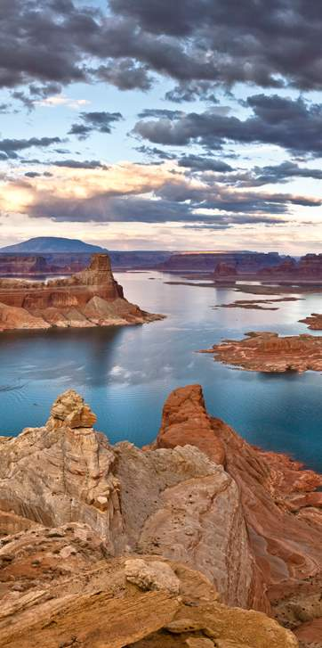
Lake Powell, Utah

MONUMENT VALLEY

After leaving Page and driving through the dismal Navajo Indian reservation, we reached Highway 163 and took it through the so-called Monument Valley, a spectacular drive which provides wonderful vistas of buttes and mesas which are absolutely spectacular and make those in Western Nebraska look like anthills by comparison. Near the end of this wonderful drive along Route 163, there is a marker which denotes it as the spot where Forrest Gump finished his ultra-ultra marathon of more than 15,000 miles. Here’s what it looks like from the north looking south:

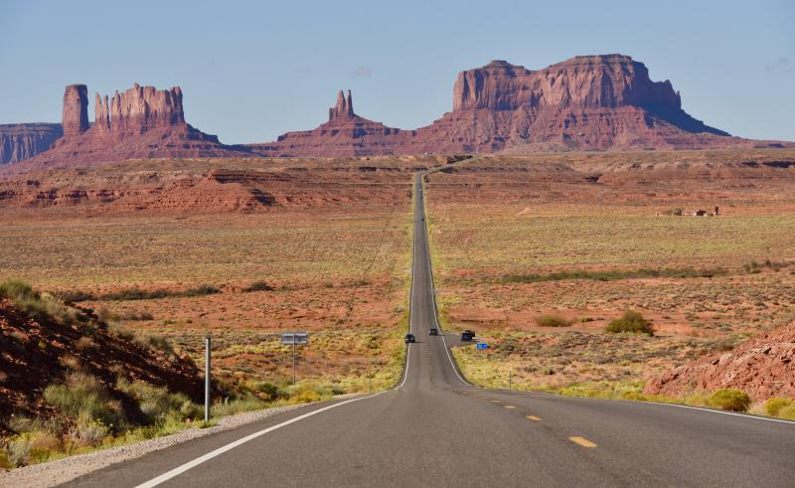
Monument Valley, looking south

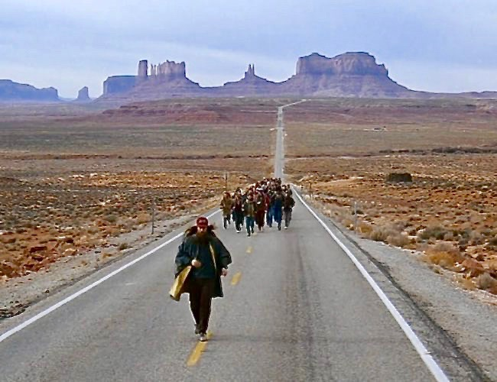
The making of Forrest Gump, the movie

UTAH’S FAB FIVE

After completing our exhilarating drive through Monument Valley, we forged on ahead through the town of Moab, our jumping off point for our visits to five different National Parks in the state of Utah. Over the course of the next two days, we visited, in succession:

Canyonlands
Arches
Capitol Reef
Bryce Canyon
Zion

each one featuring some of the most spectacular geological formations you will ever see, only to be topped by the next one. Between HQ and me, we took hundreds of photographs at these five National Park treasures, and it would be impossible to cull out the best from each park in time for our press deadline for this issue of FTB, so I will just include a small sampling of what we were able to capture on our iPhone cameras:

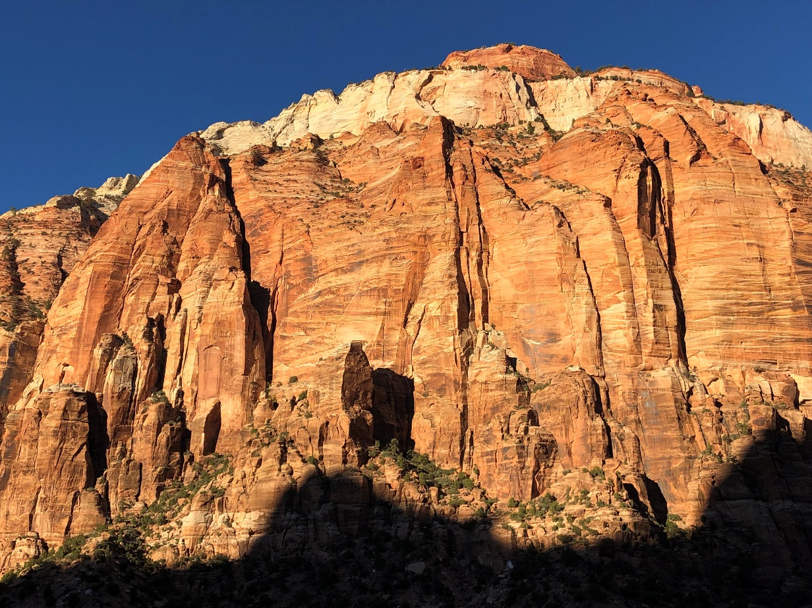

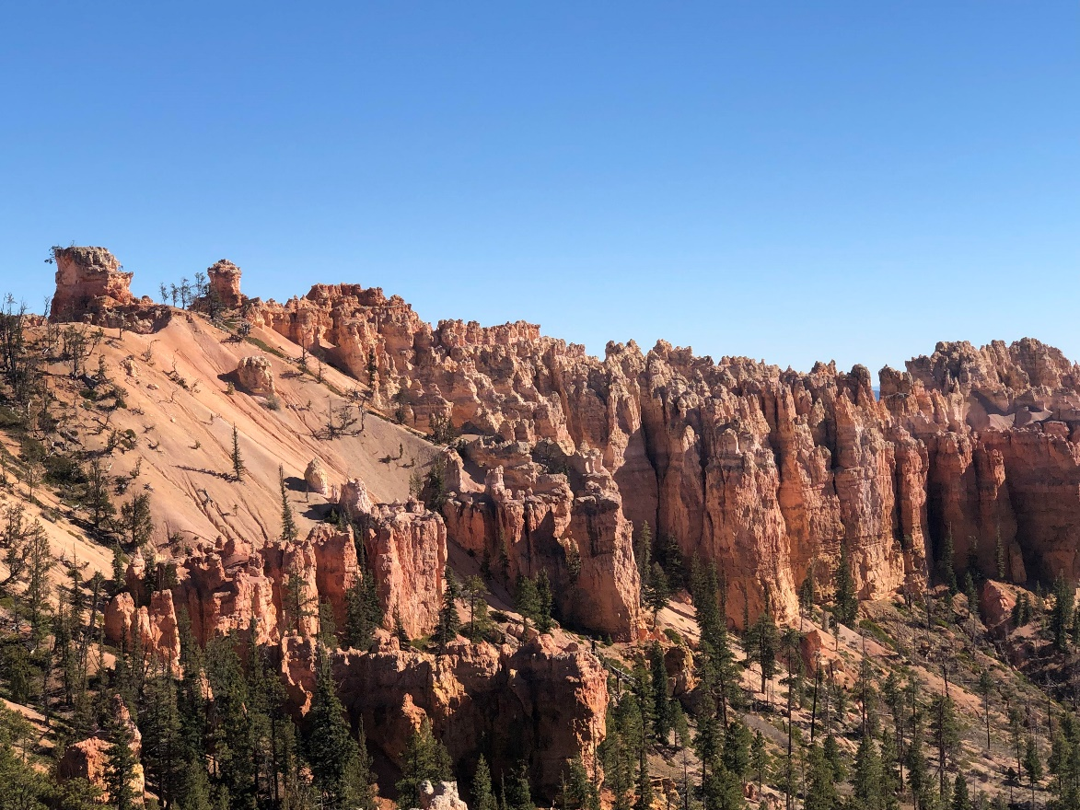

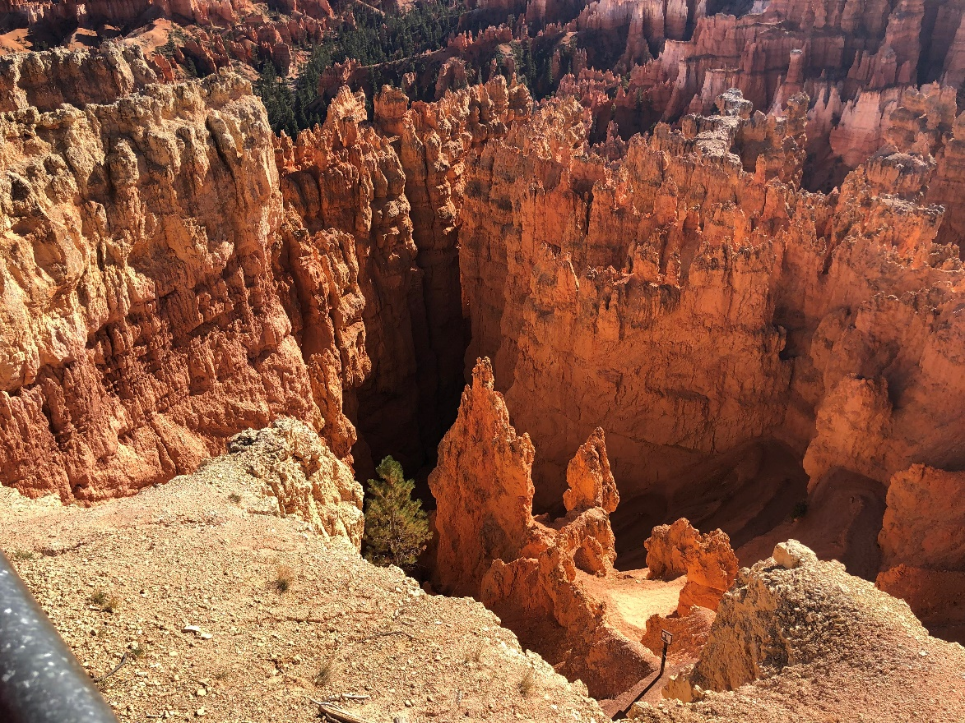

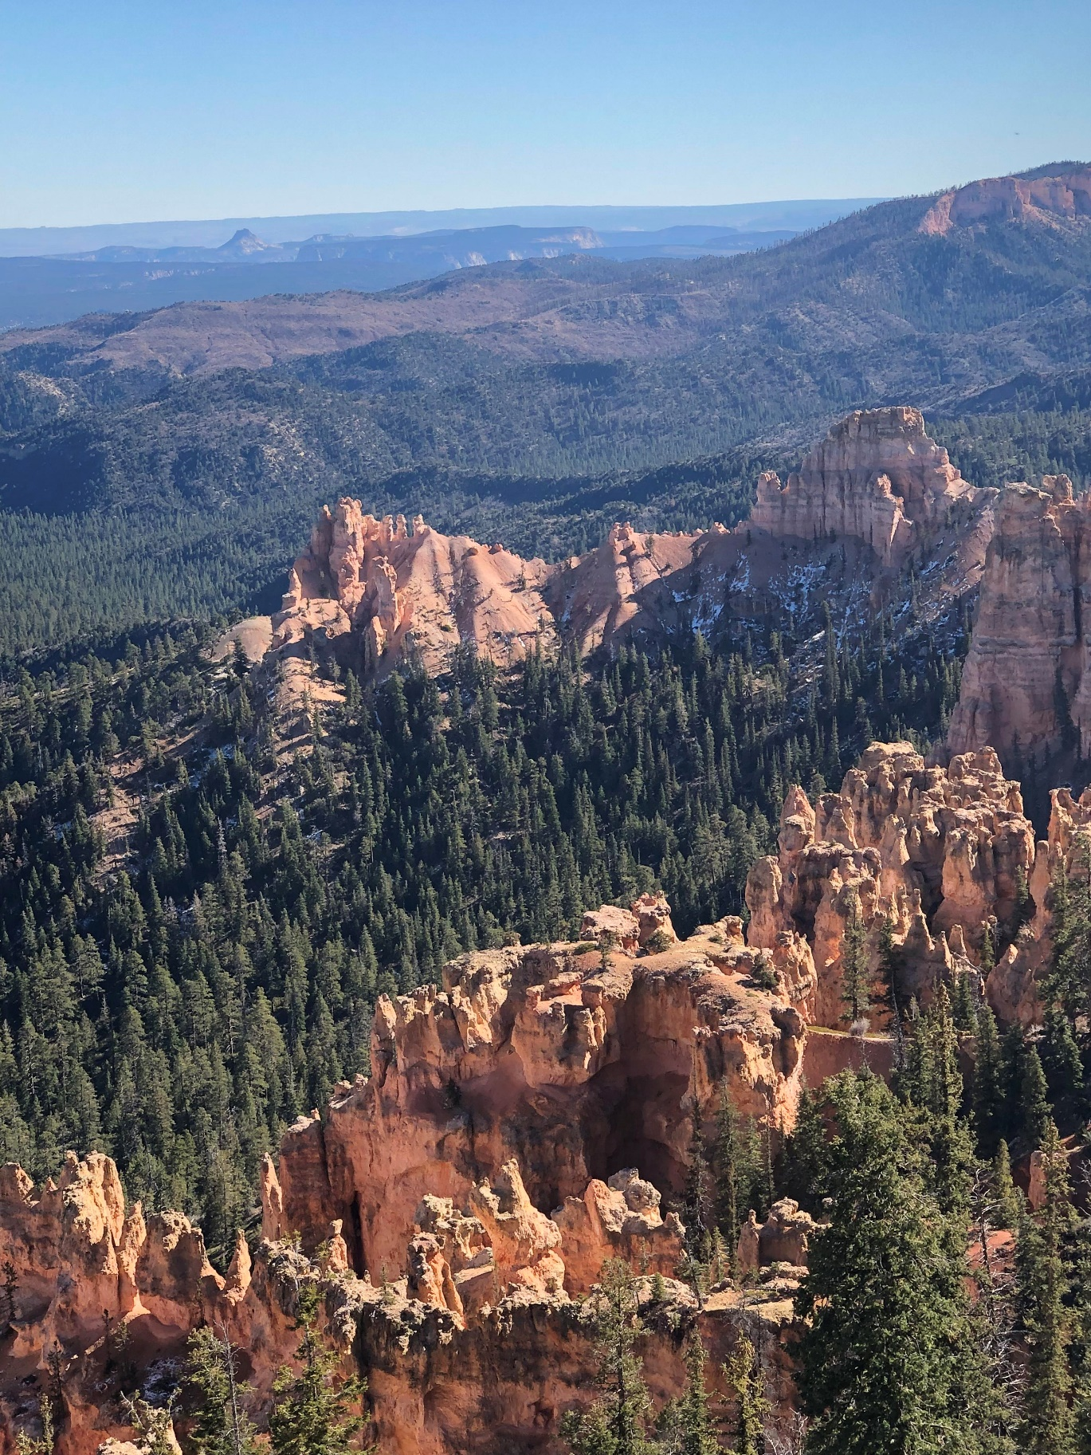

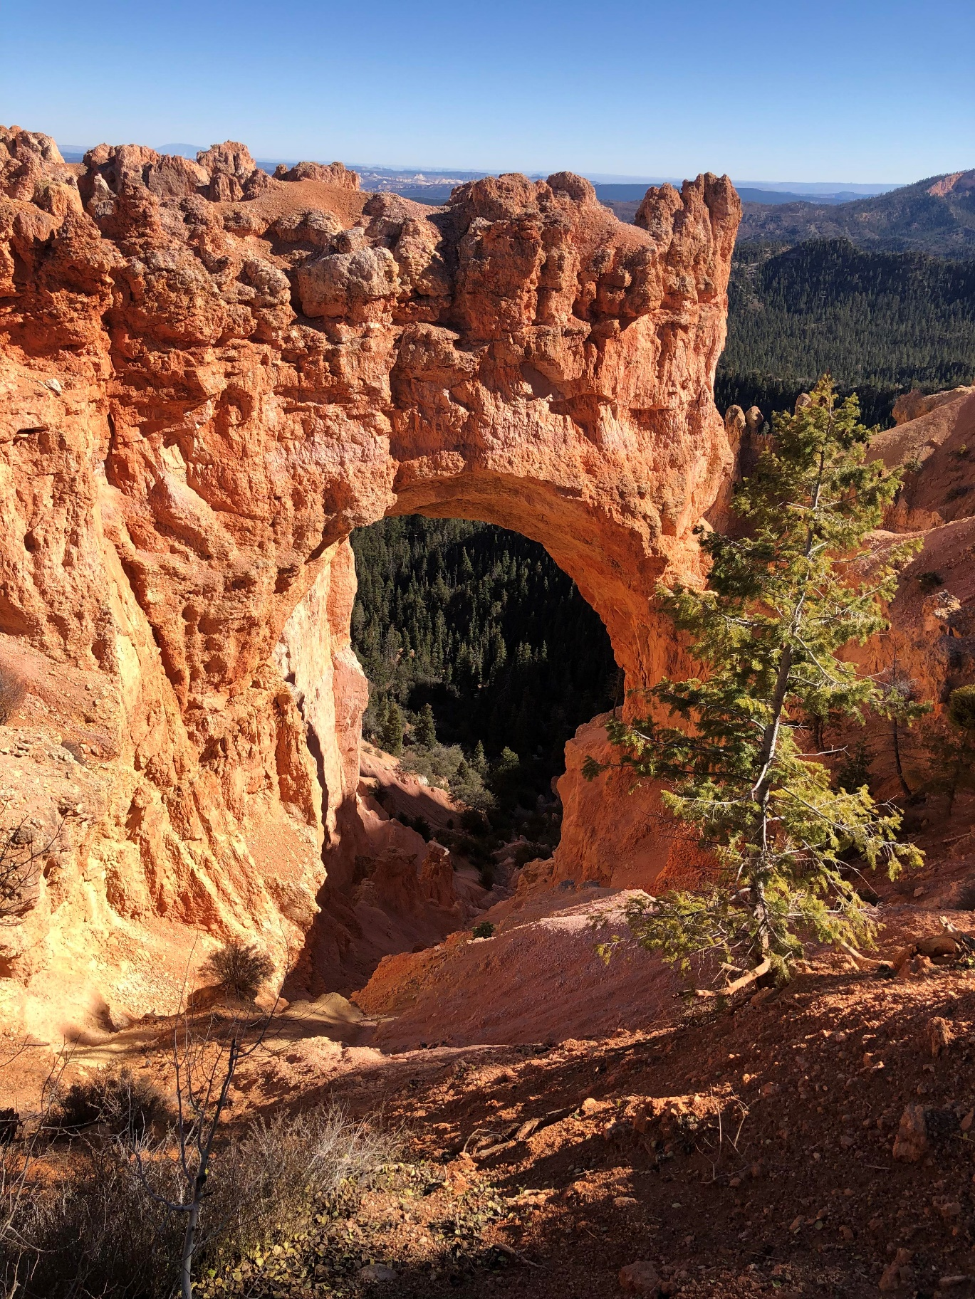

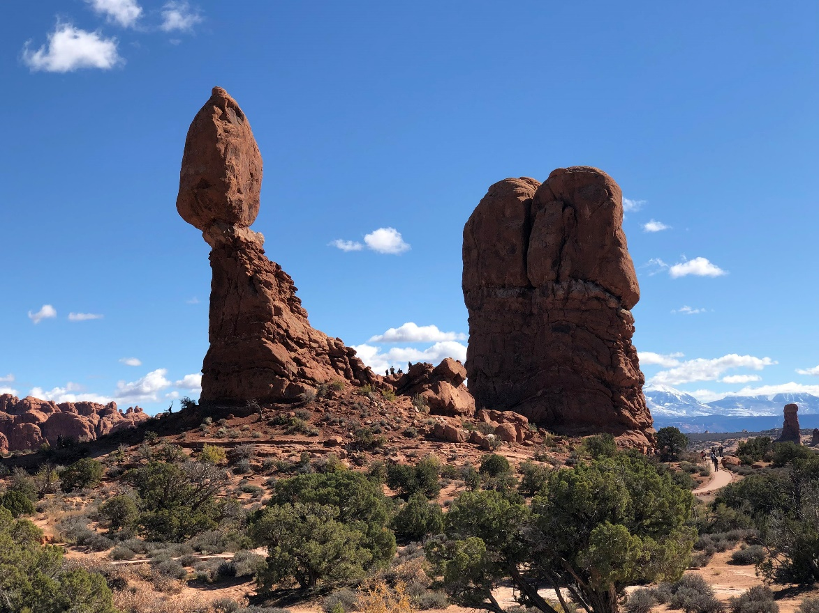

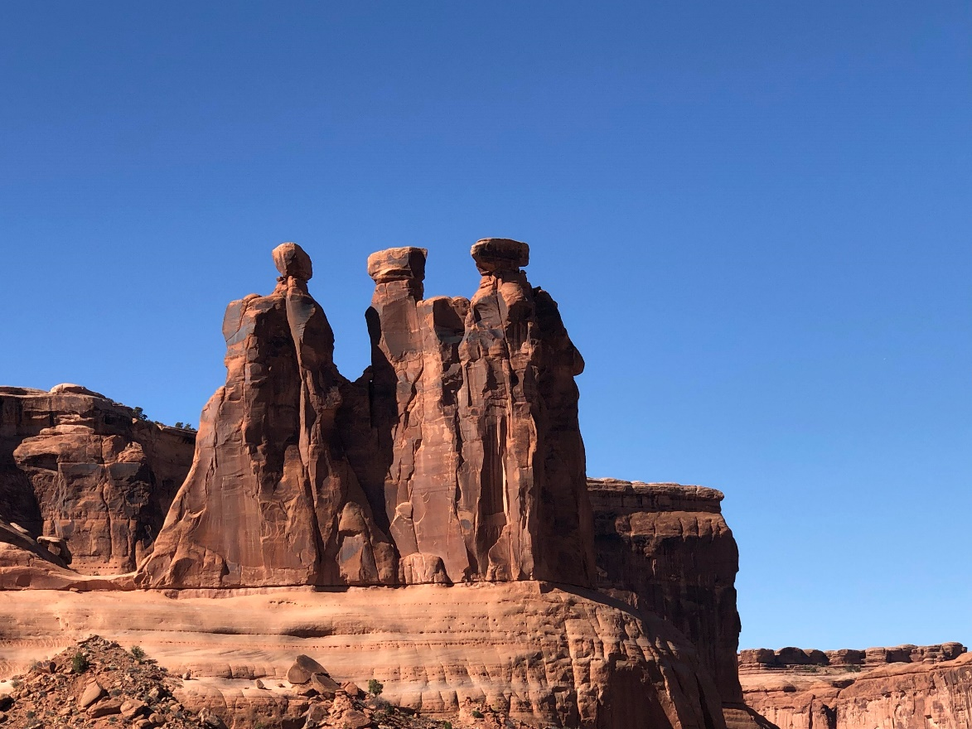

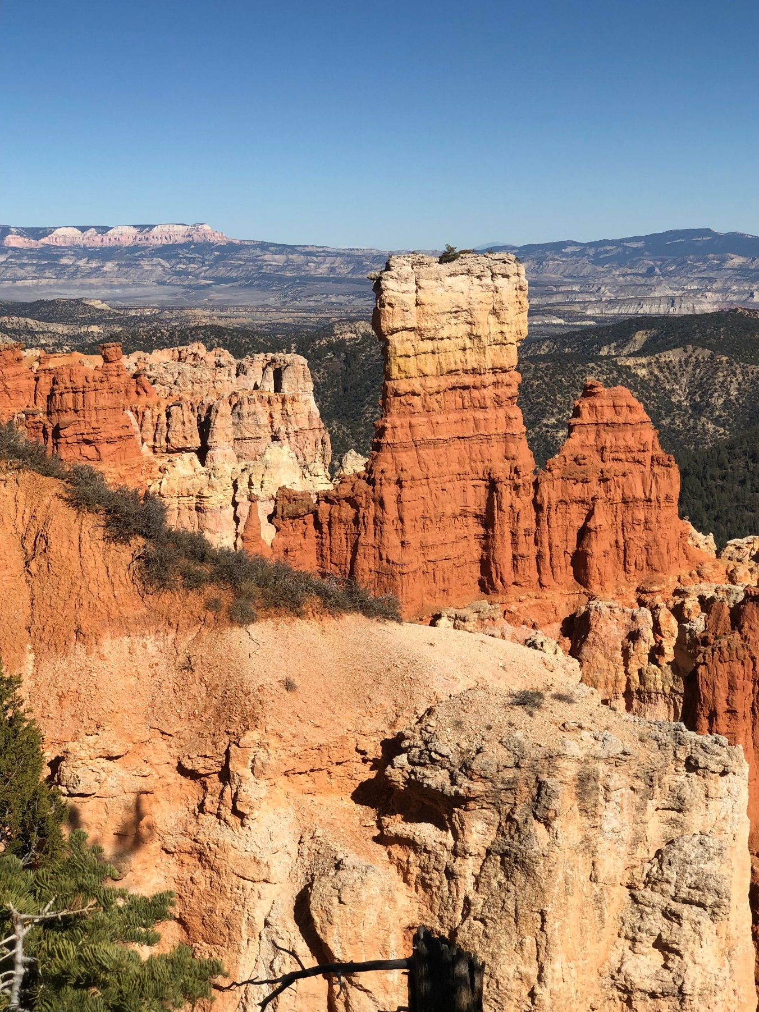

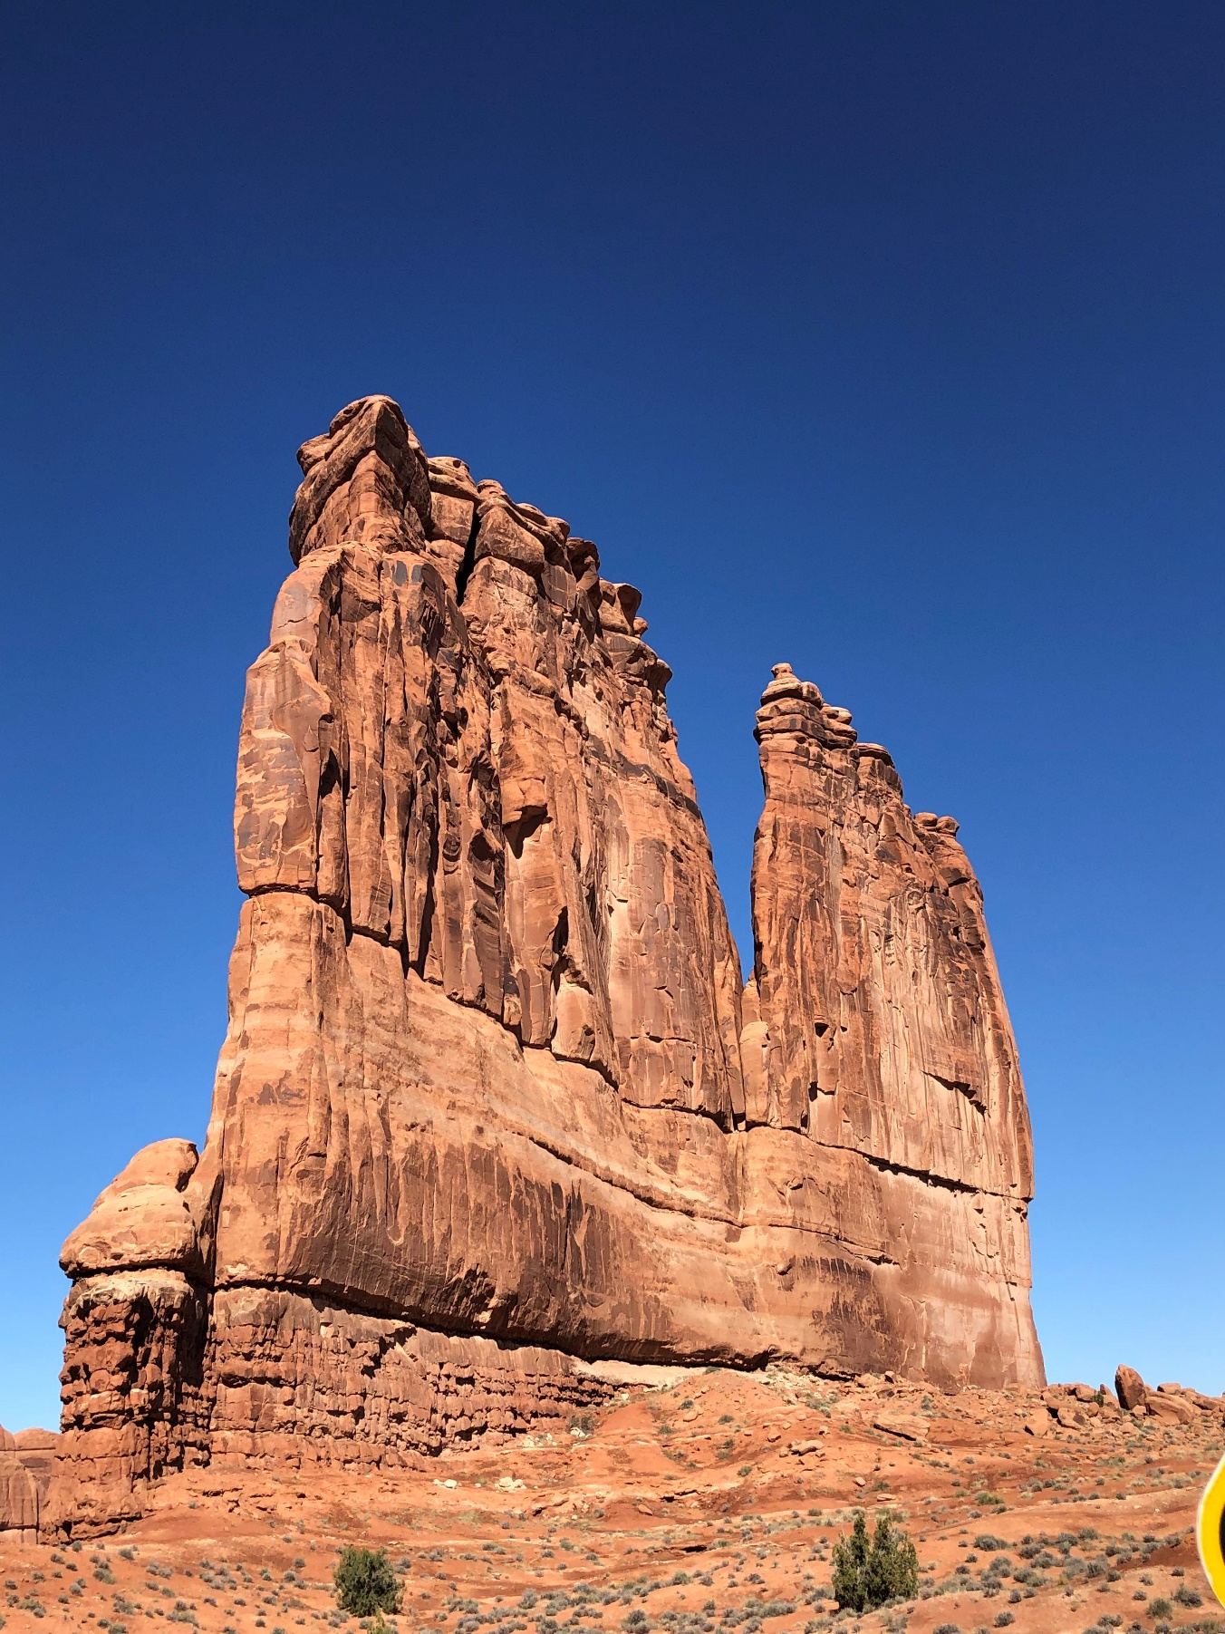

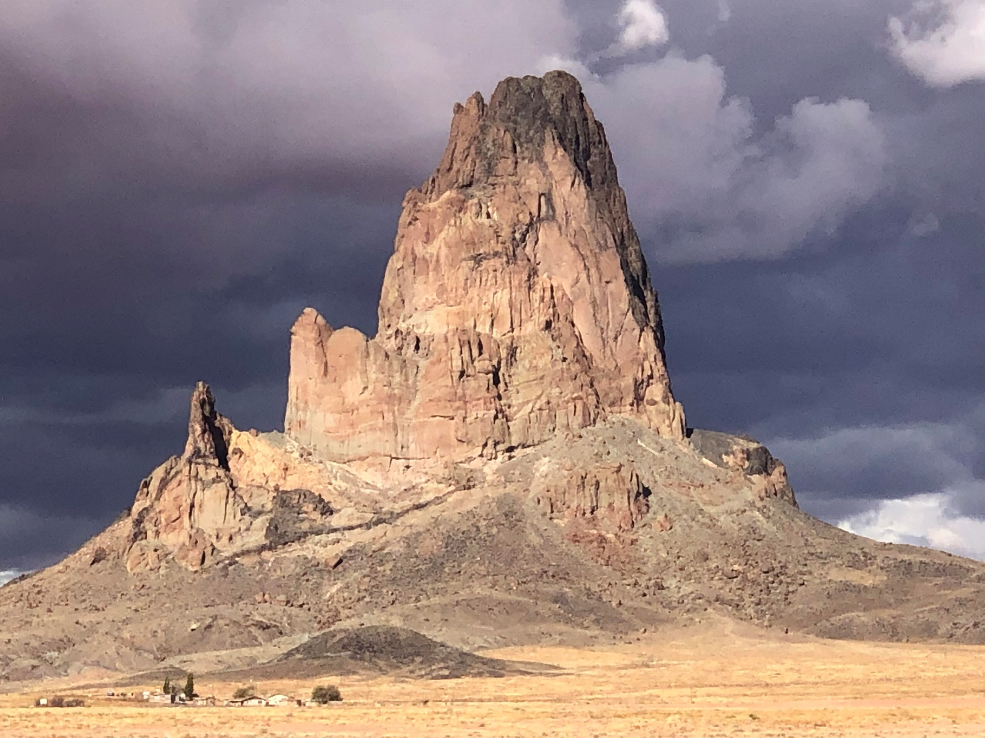

If you ever get a chance to visit the Fab Five in Utah, you should absolutely take it. And if you do, make sure and take the scenic drive on Route 163 through Monument Valley; the drive on Highway 128 along the Colorado River from Moab to Cisco, Utah; and the drive along scenic Highway 12 from Torrey, Utah to Bryce Canyon, one of the most beautiful drives you will ever take in your entire life, I promise you.

After our visit to Zion National Park, the last of the Fab Five that we saw, we drove to St. George and spent the night there before taking Highway 59 through Colorado City, AZ, to Fredonia, Arizona, where we picked up another scenic highway, 89A, which took us past the wondrous Vermilion Cliffs before our return to Flagstaff and then Phoenix. We picked a great time of the year for this trip, since the kids are in school and the crush of the summer and early fall vacation season was over, and the National Parks were not overcrowded; and because the Aspen trees and other fall foliage were in full color and delightful to see.

III. NOT ONCE, NOT TWICE, BUT THRICE

A client of mine stopped by the office the other day and gave me a gift to show his gratitude for the successful results of a jury trial in which I defended him in July, in a case involving an alleged case of medical malpractice in surgically replacing the patient’s left knee joint with an artificial knee. In closing arguments, I implored the jury with the entreaty that the suing plaintiff was “a nice lady, but she got bad advice from others, not once, not twice, but thrice.” Knowing of my love of baseball, Dr. Crabb rewarded my efforts with a baseball bat with this saying engraved on it, shown in the picture below, and told me he thought that this was probably the only time in the history of jurisprudence that this specific argument was ever made.

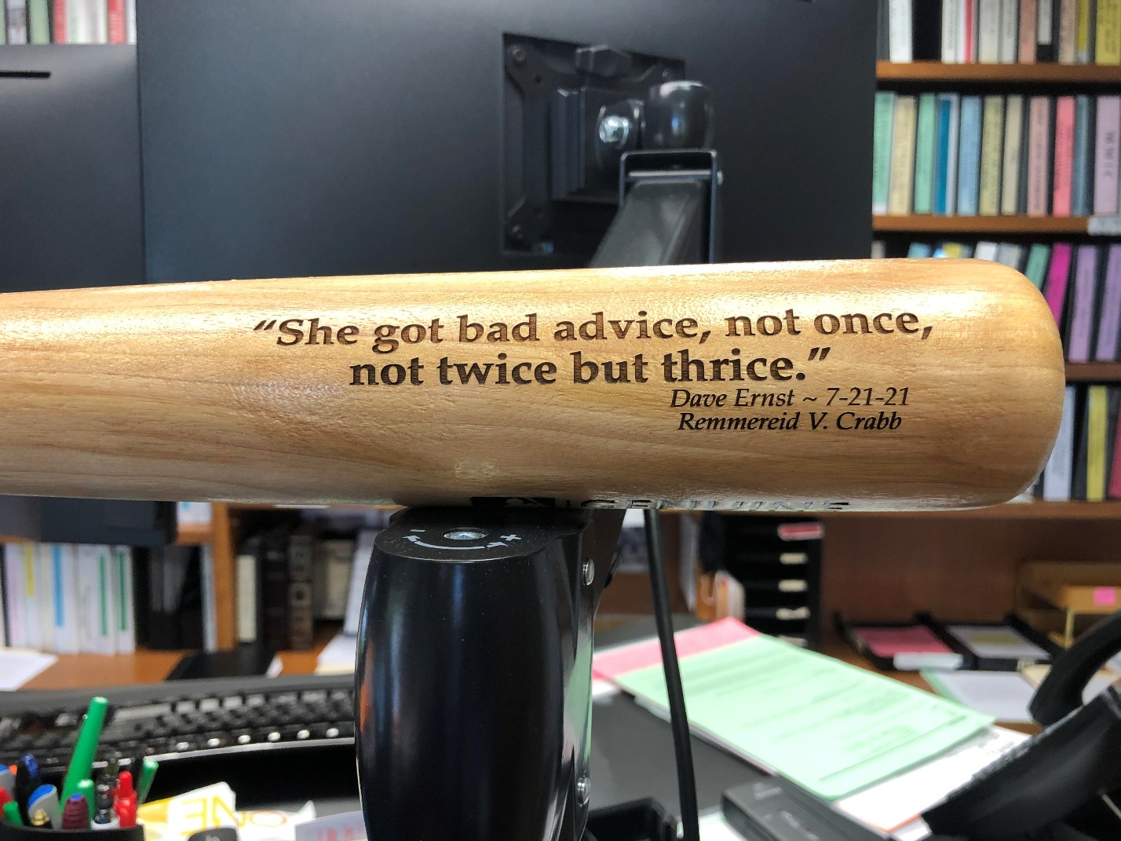

I told Dr. Crabb that this was my favorite client gift that I have ever received, ranking ahead of even over the original Comiskey Park bleacher seat that a physician client gifted to me way back in 1992 after a grueling two-week jury trial across a Labor Day weekend, which bleacher seat still adorns my law office. It’s good to have appreciative clients.

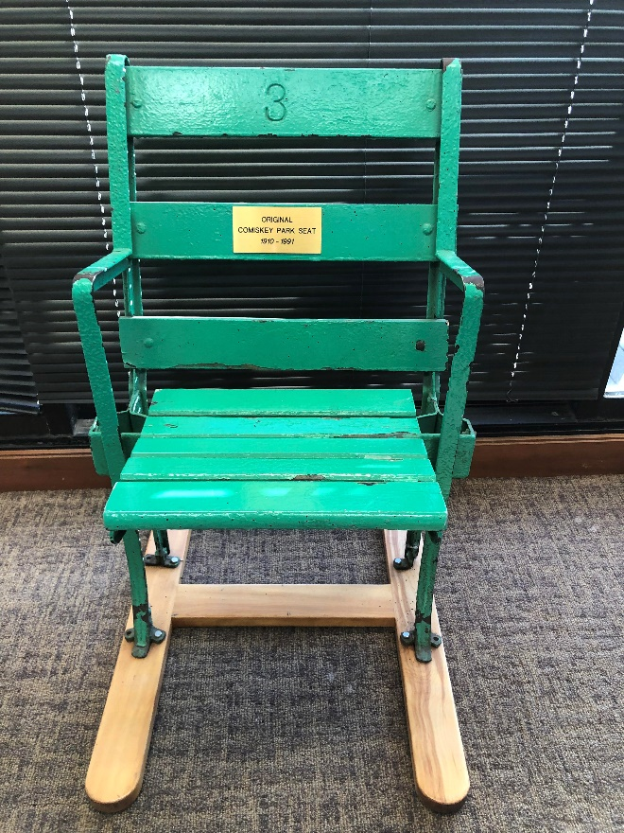

IV. BOOK REPORT
THE GRAPES OF WRATH

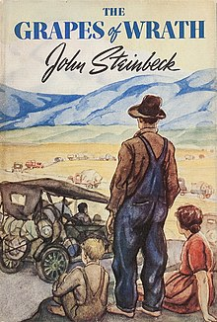
Deciding that I needed to mix in a novel of literary significance with my usual reading regimen, I recently finished The Grapes of Wrath, by John Steinbeck, published in 1939. Most of you who had decent high school educations probably have already read this book, but my English teacher in high school, Dr. Strange, probably knew that such a classic of literature would have been far too much for a simple-minded Rocket High attendee, and so he instead introduced us to Dr. Seuss books like Fox in Socks and Green Eggs and Ham, and showed a lot of newsreel movies during class. But I digress.

Not being familiar with Steinbeck’s style of writing, The Grapes of Wrath was quite a slog for me, and took me almost a month to muddle through. Having done so, I would like to be able to say that I am the richer for it, but the ending was so disturbing that I frankly sort of wish that I had tackled a different literary classic. Enough said.

V. 65 REVISITED

Being someone who tends to reflect back a lot, I have been reflecting wistfully on the October 16 gathering at the Lucky Bucket Brewery for my surprise birthday party, and it was such a great feeling to be there with family and friends, that the only thing I can compare my emotions to is--another Chevy Chase movie reference here--the feeling that Clark Griswold had when his Christmas lights finally worked after the initial disastrous attempts. Pure pride and joy.

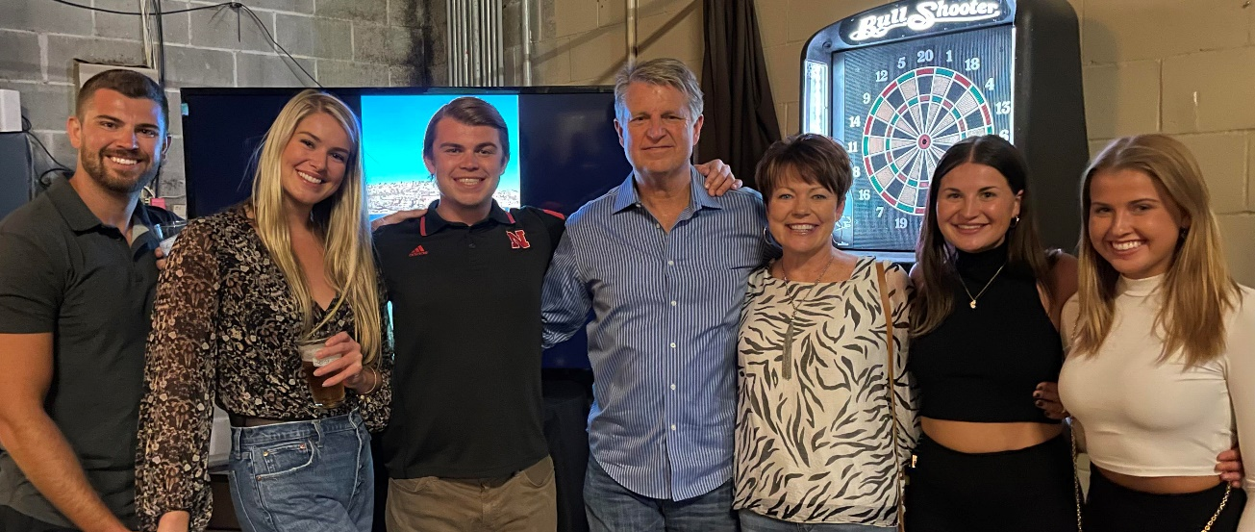

Thanks again, all.

VI. FRIDAYS WITH SKIPPER

Now that I am 65 and no longer working on Fridays, I decided that to help keep myself out of the bars and bordellos, I should find something constructive to do with my time on Fridays, and what better way to spend them than with friends and family. So this will essentially be the polar opposite of Tuesdays with Morrie--wherein Morrie dispenses all kinds of wisdom to the author of that book, Mitch Albom--and instead it is my hope that I can gain wisdom, insight and perspective from hanging out with friends, old and new, on Fridays.

My first Friday with Skipper was spent with a character with a whole lot of character, our own beloved Underbelly, whom I met up with last Friday for lunch at Laslo’s in Lincoln, followed by a trip down Memory Lane driving through northeast Lincoln and the neighborhoods where we were raised. As expected, it was three hours that were very well spent, as we discussed religion, politics, the state of the union, baseball, and various and sundry other topics. Bob has as positive a view on life and living as anyone I know, and one can’t help walking away from meeting with Bob feeling anything other than uplifted and, of course, amused. In reflection, it occurred to me that we would all benefit from another of his prized Bellyflops, and so he has agreed to share his wit and wisdom with all of us next week.

VII. THE END

In the timeless words of Frasier Crane, thanks for listening, amigos. Next issue of FTB: (1) Winter Meeting; and (2) The Trip. Next week: THE BELLYFLOP!

Skipper

More later on Forrest.
Her.
What, no exhibition games? What does she have against the Grapefruit League anyway?
With whom I share a birthday.
Emily’s roommate.
I know what you’re thinking: No, you won’t.
To borrow a line from Clark Griswold in National Lampoon’s Vacation.
Which town will be familiar to you if you ever read Under the Banner of Heaven, by Jon Krakauer, a fundamentalist Mormon stronghold where bigamy is not only tolerated but encouraged.
His actual name, and true to it, he was quite strange.

